**Name: Riddhesh Naik**

**Roll No: 225**

**CYBER FORENSICS PRACTICAL 7**

**Aim: -** Email Forensics using AccessData FTK.

**Steps –** To create files and delete them in Microsoft Outlook

Start Microsoft Outlook and Click on New

Type the message and the receiver’s email ID and save it

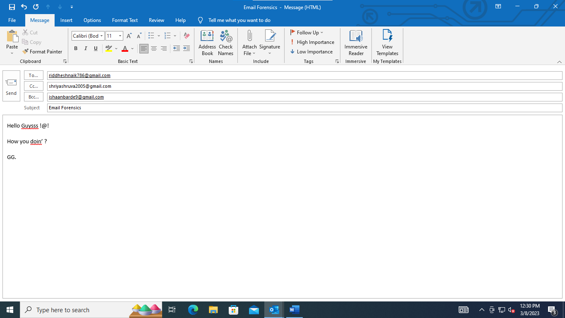

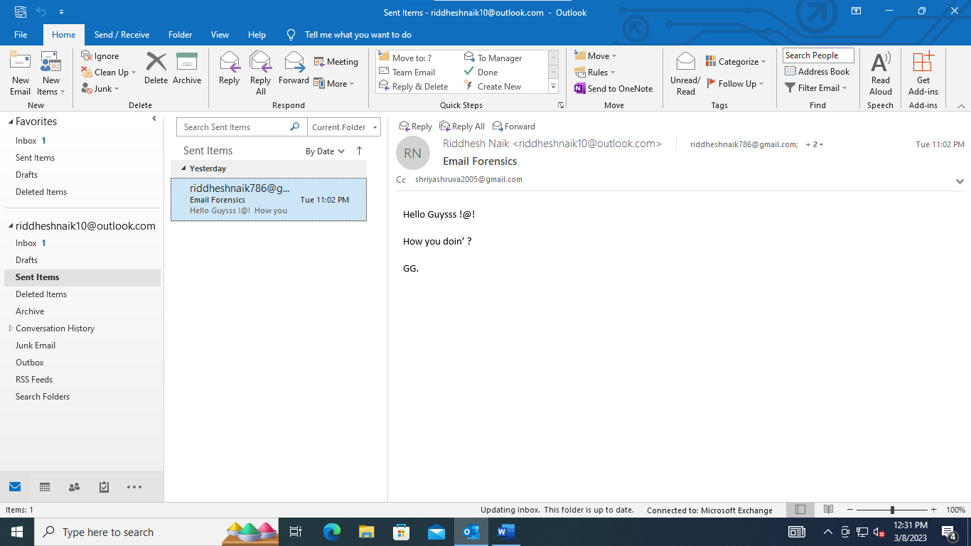

Go in the Outbox section and delete the mail

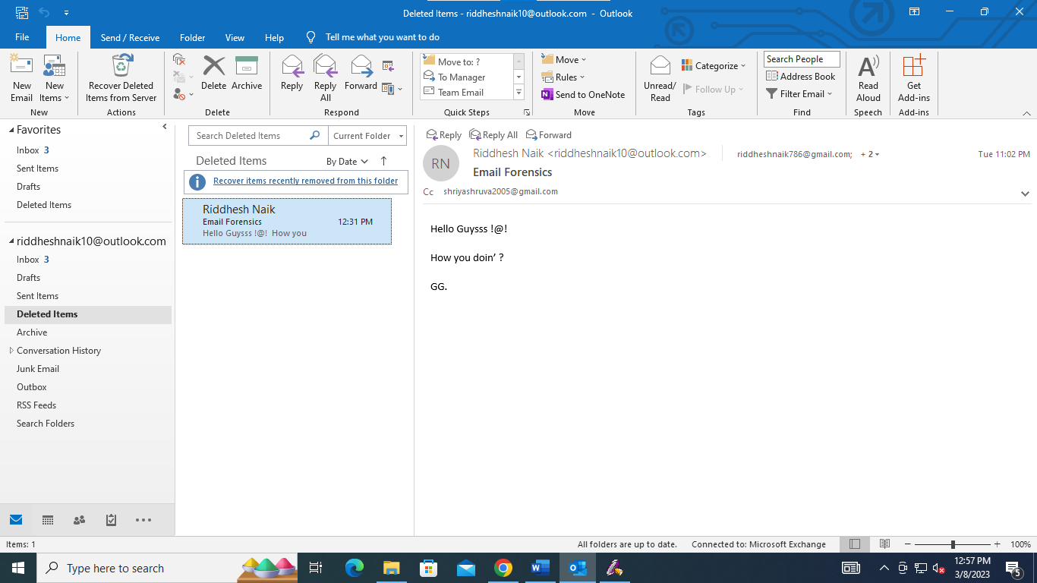

Go to File => Open & Export

Select Import/Export

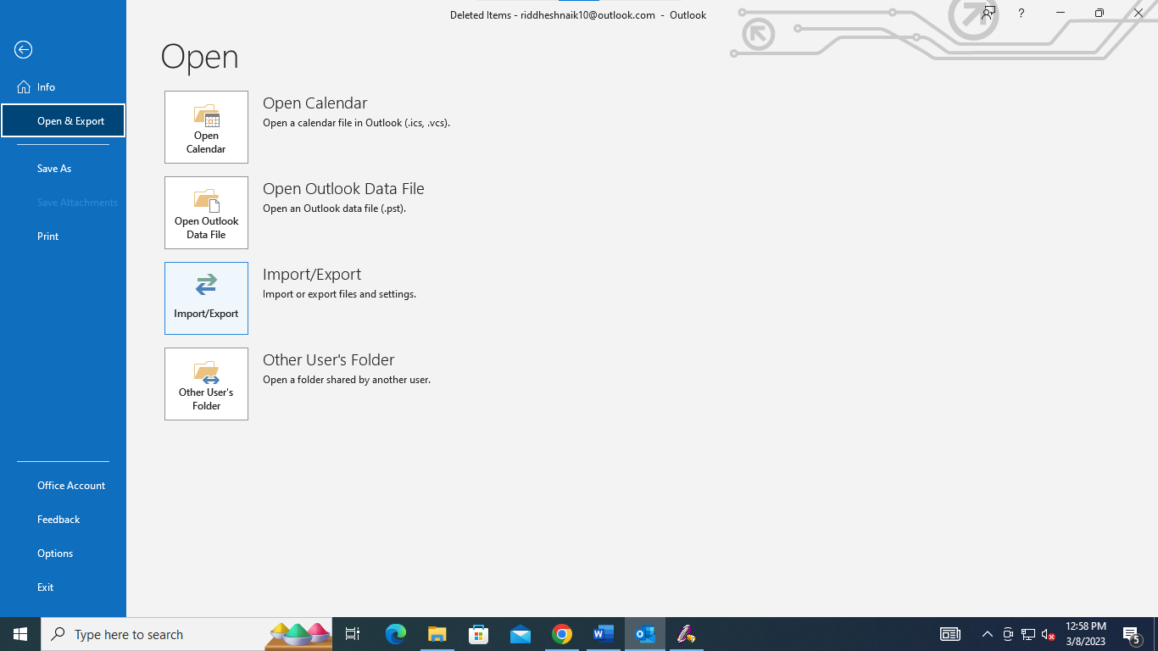

Select Export to a file

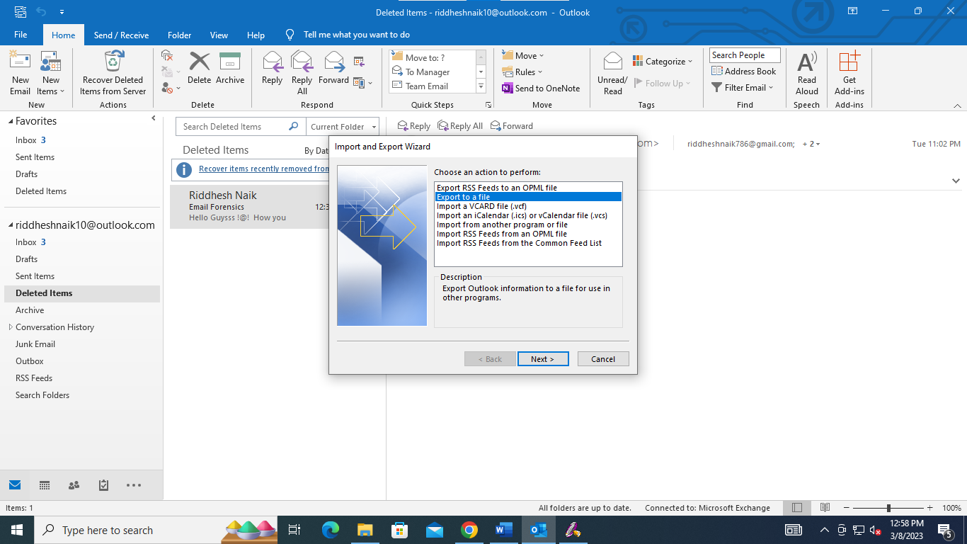

Select Outlook Data File (.pst)

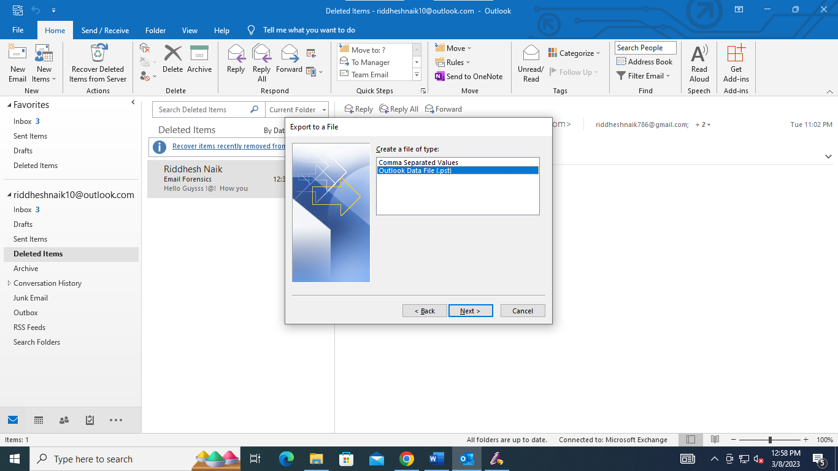

Select the folders you want to export

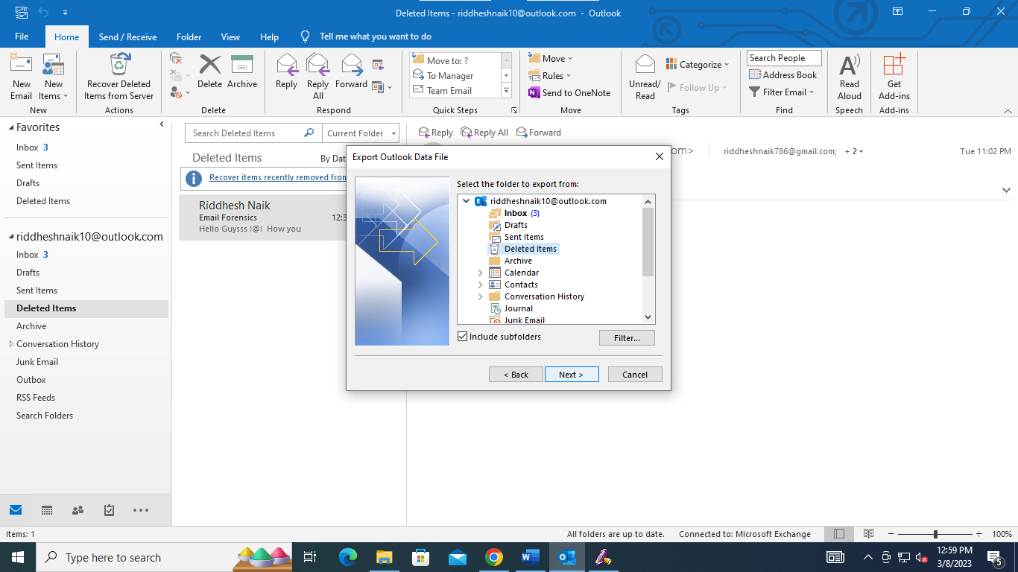

Save the exported file

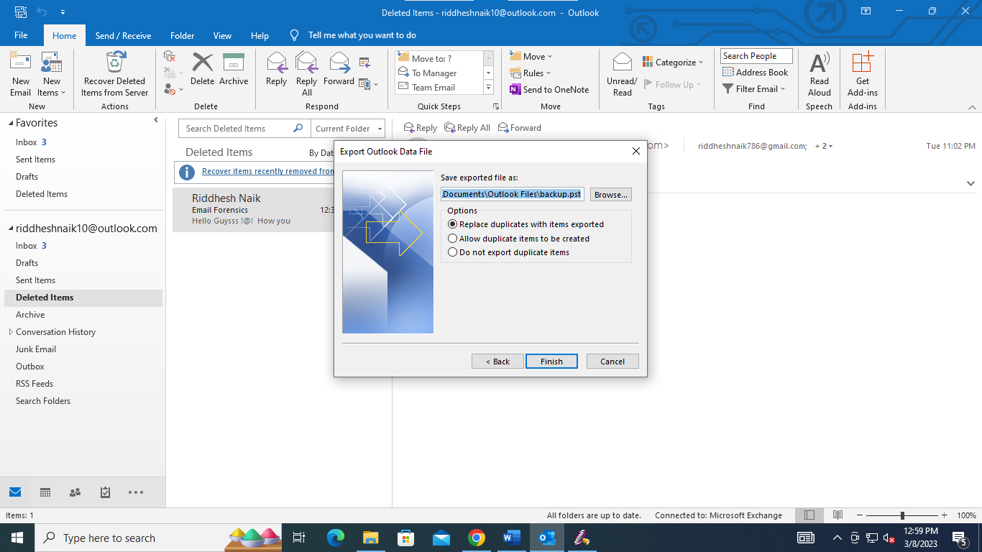

Create Outlook Data Look File password

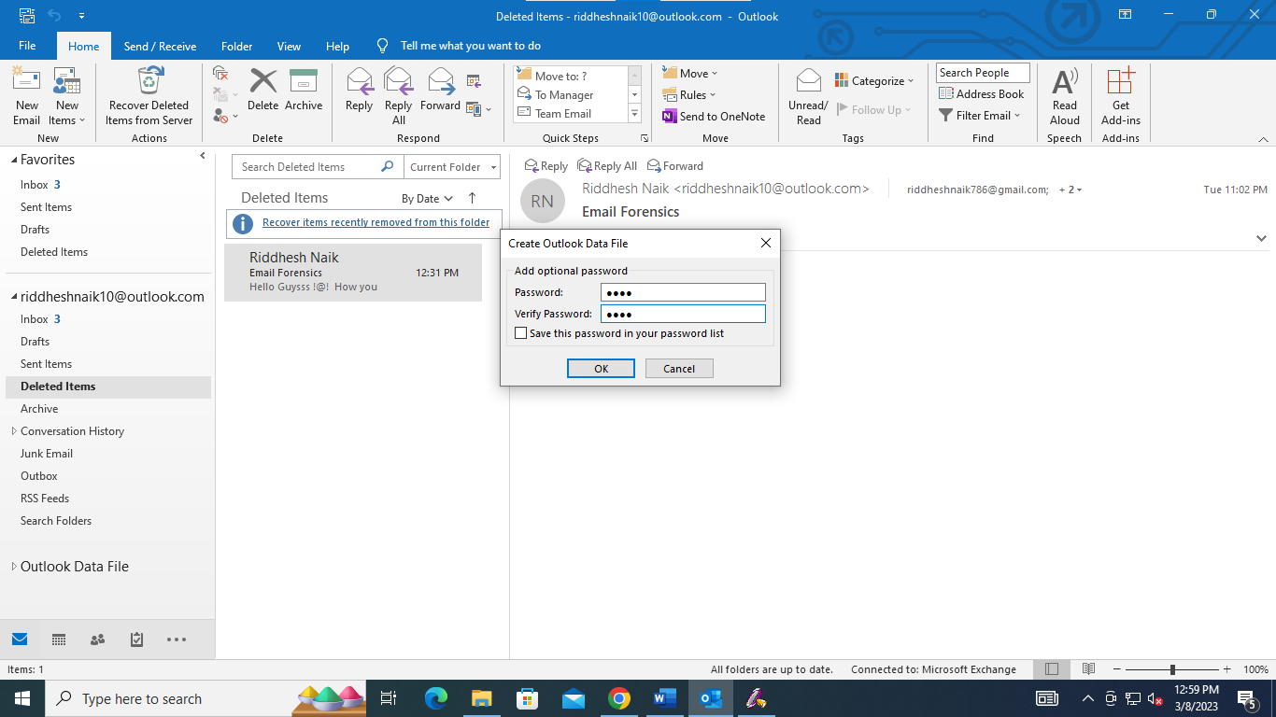

Type the password to take the backup

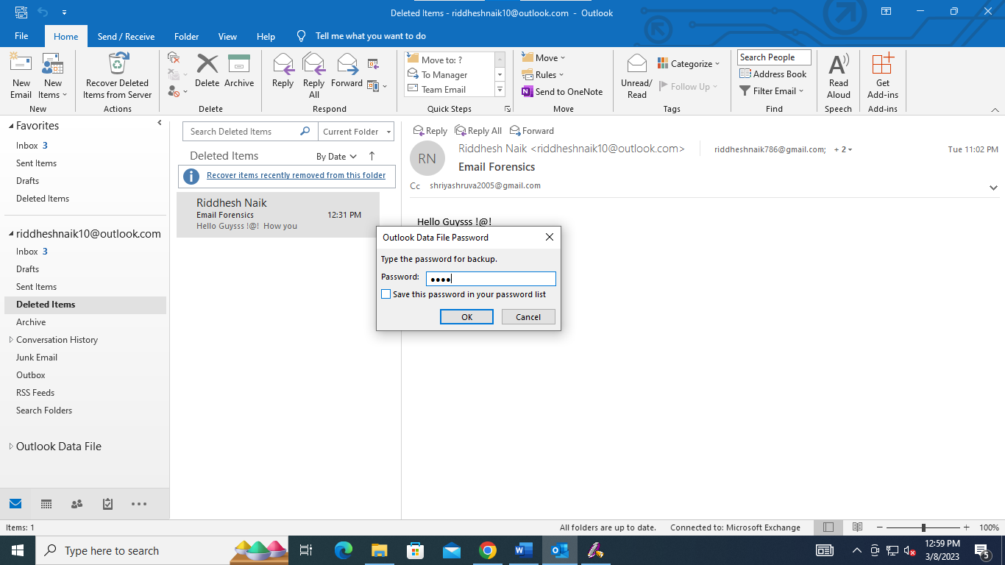

Start AccessData FTK. When the AccessData FTK Startup dialog box opens, click Start a new case, and then click OK.

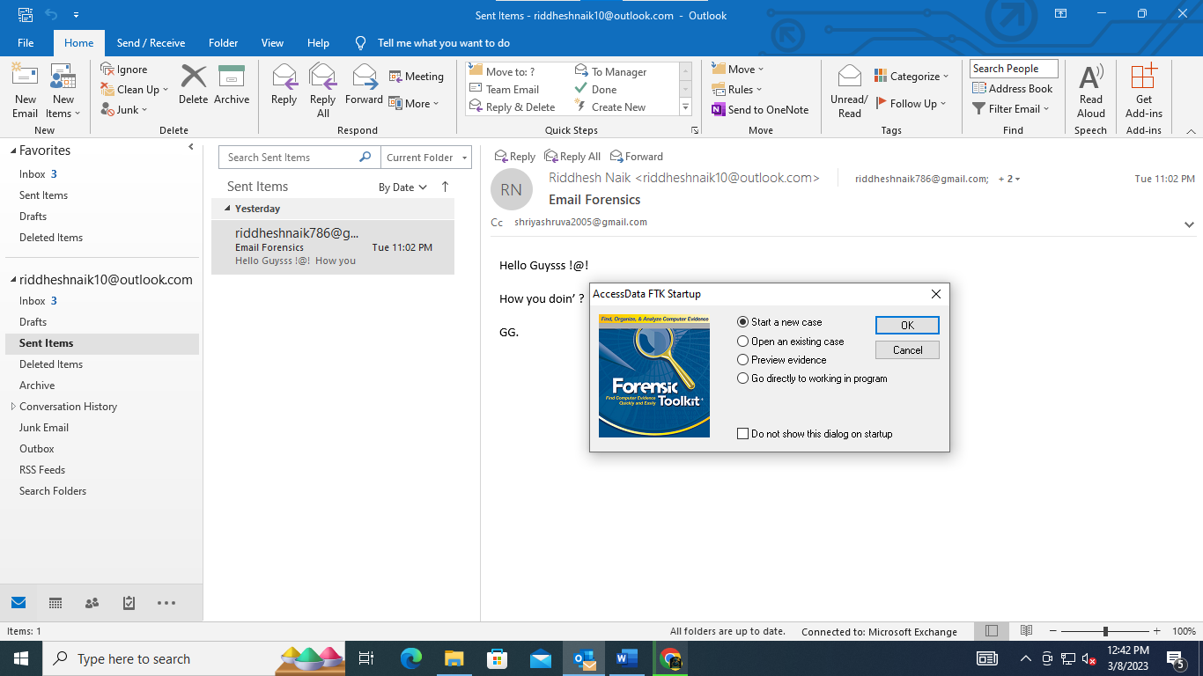

In the New Case dialog box, type your name for the investigator name, and type t for the

case number and case name. Click Browse, navigate to and click your work folder, click OK,

and then click Next.



In the Case Information dialog box, enter your investigator information, and then click Next.

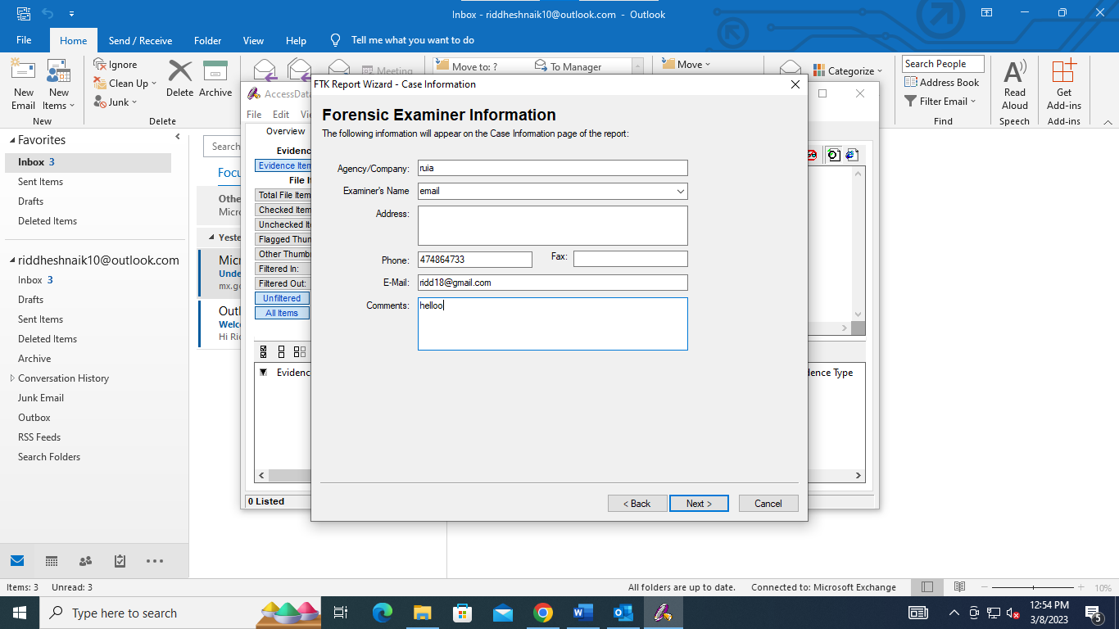

Click Next until you reach the Refine Case - Default dialog box

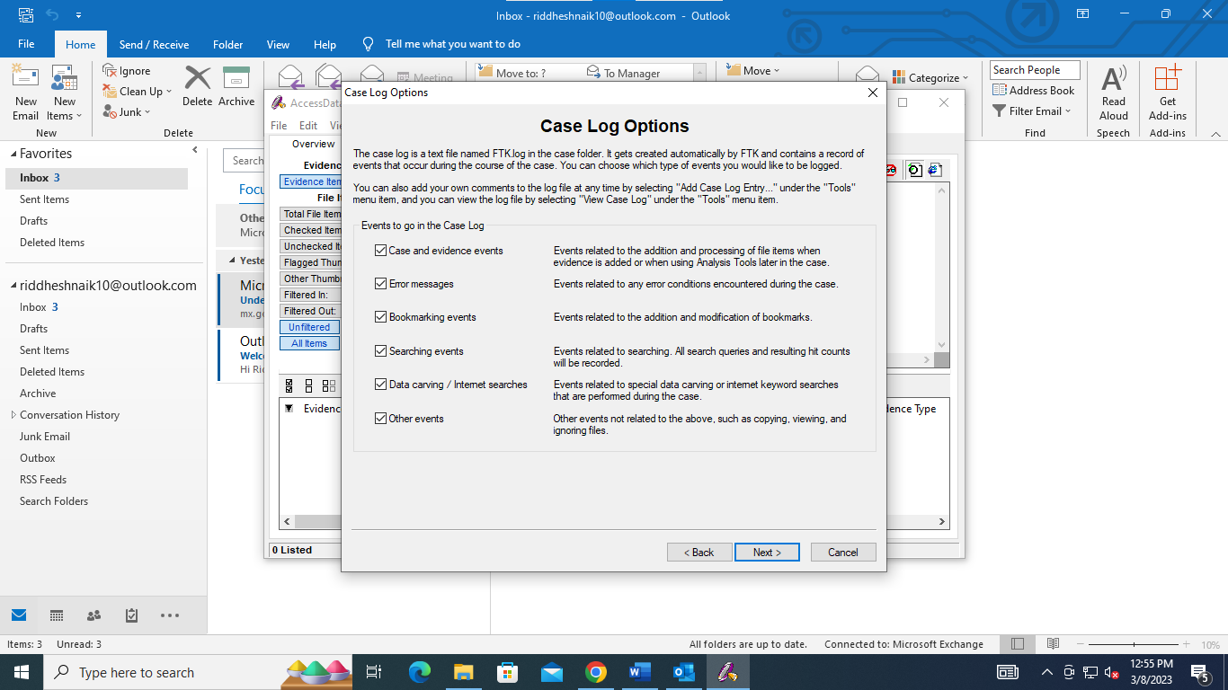

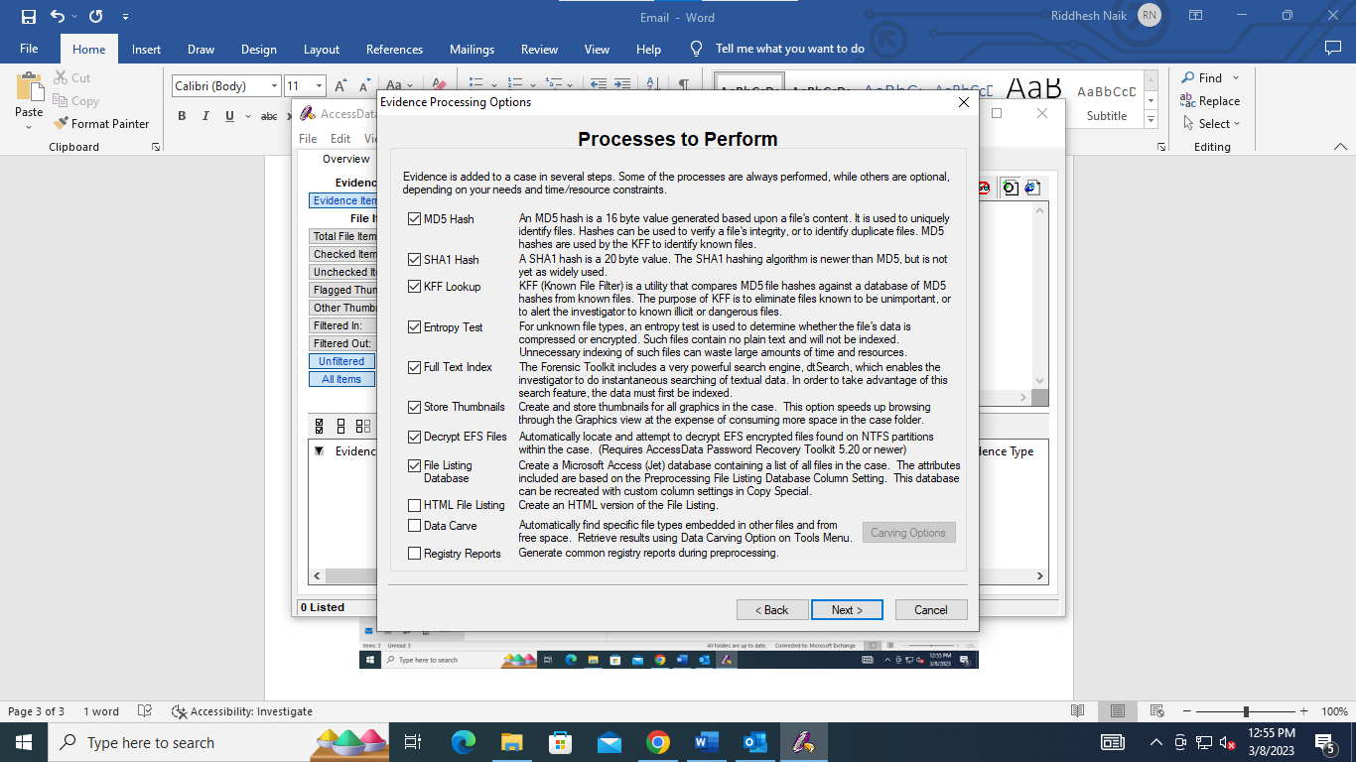

Click the Email Emphasis button, and then click Next.

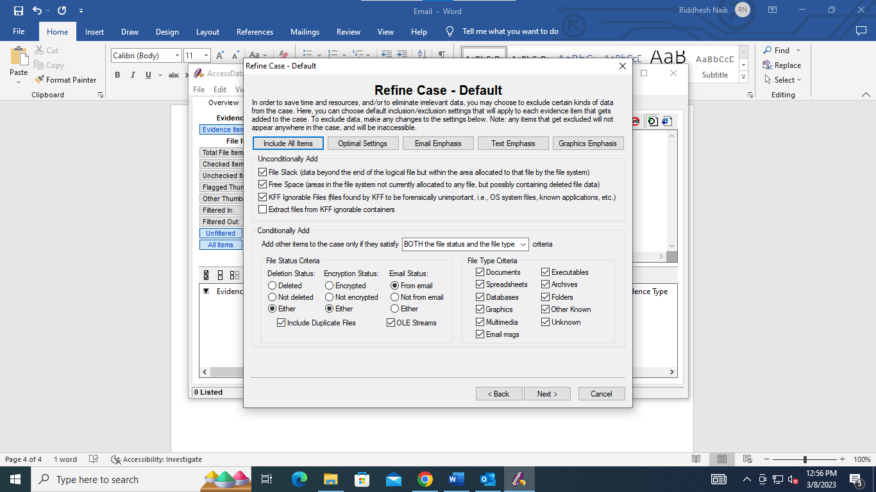

Click on Add Evidence. Select individual file and click continue.

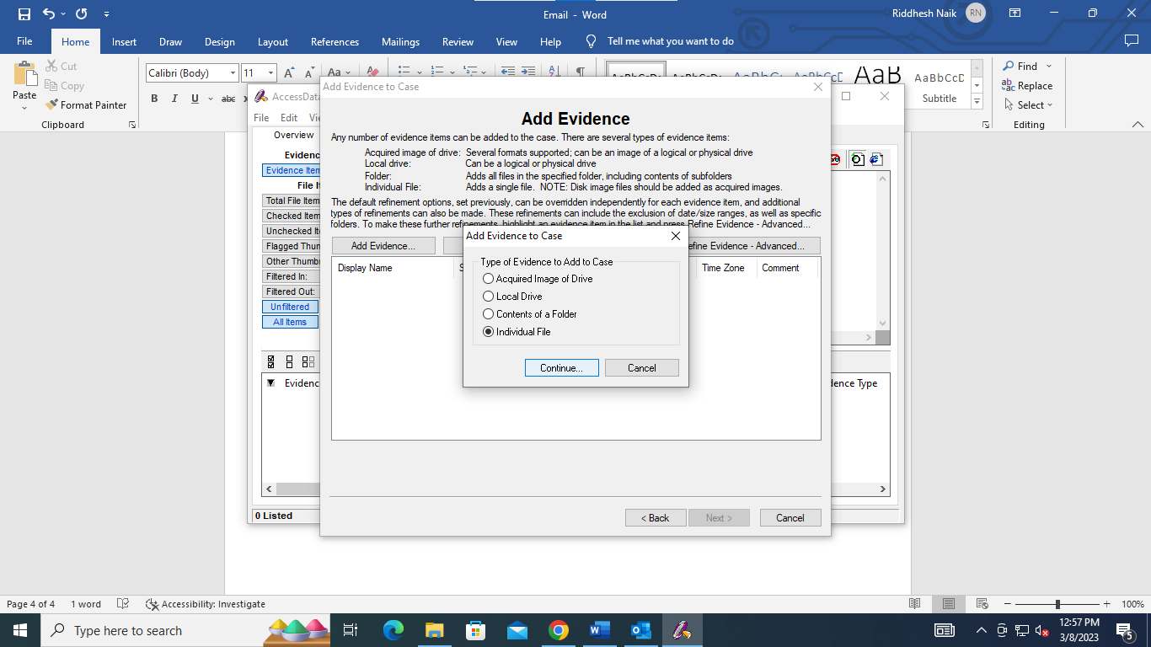

Select backup.pst file.

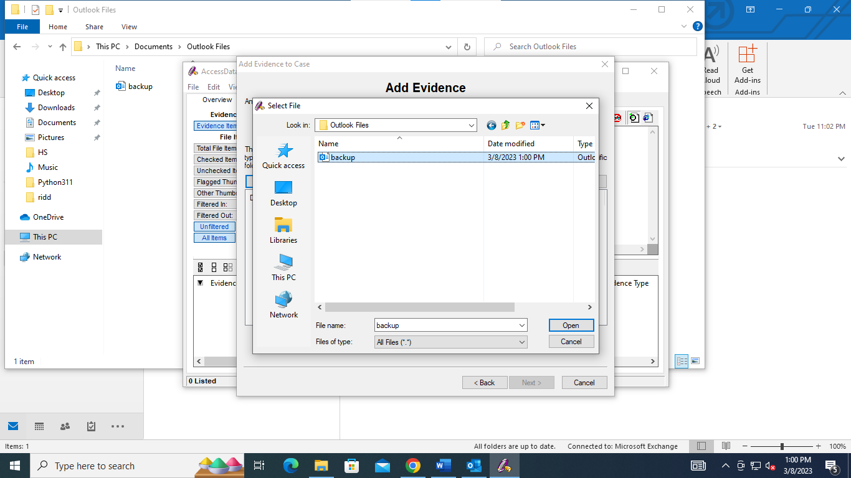

Give basic information about the evidence

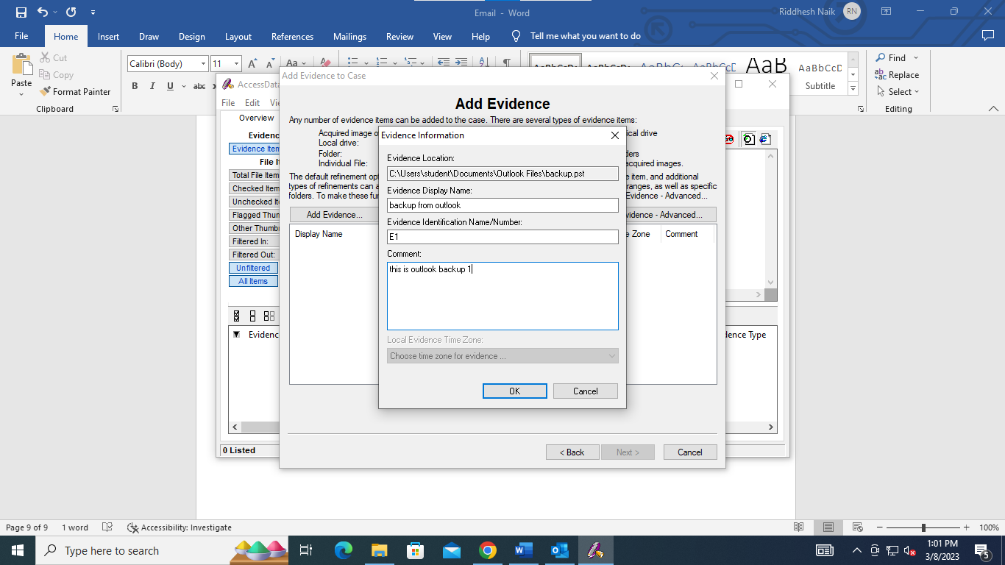

Click Next

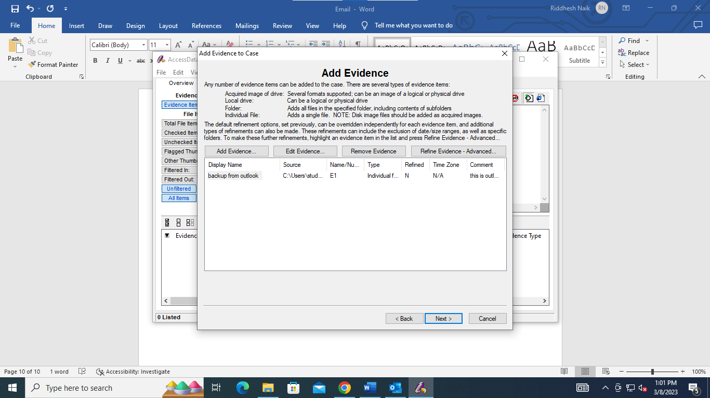

Click Finish

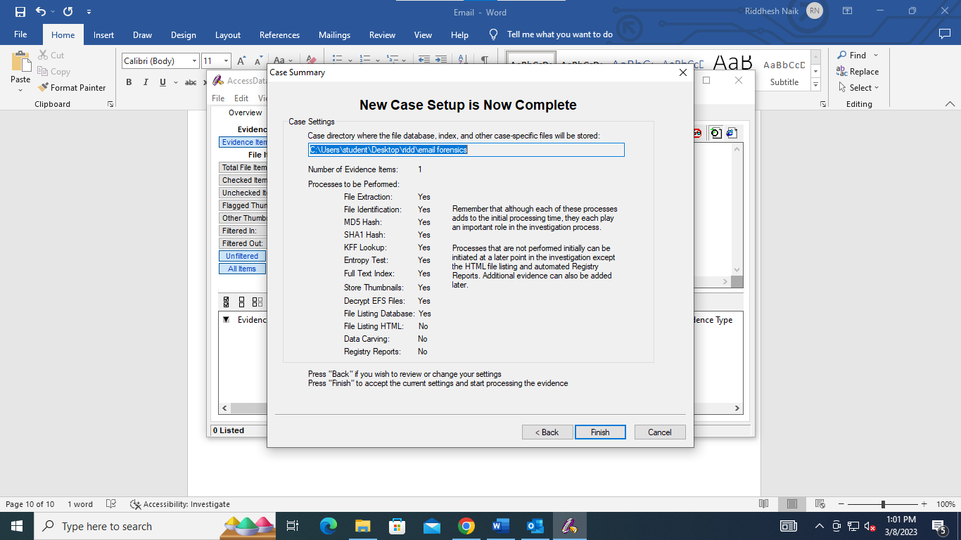

Click on Email tab in Access Data FTK.

This is the deleted email

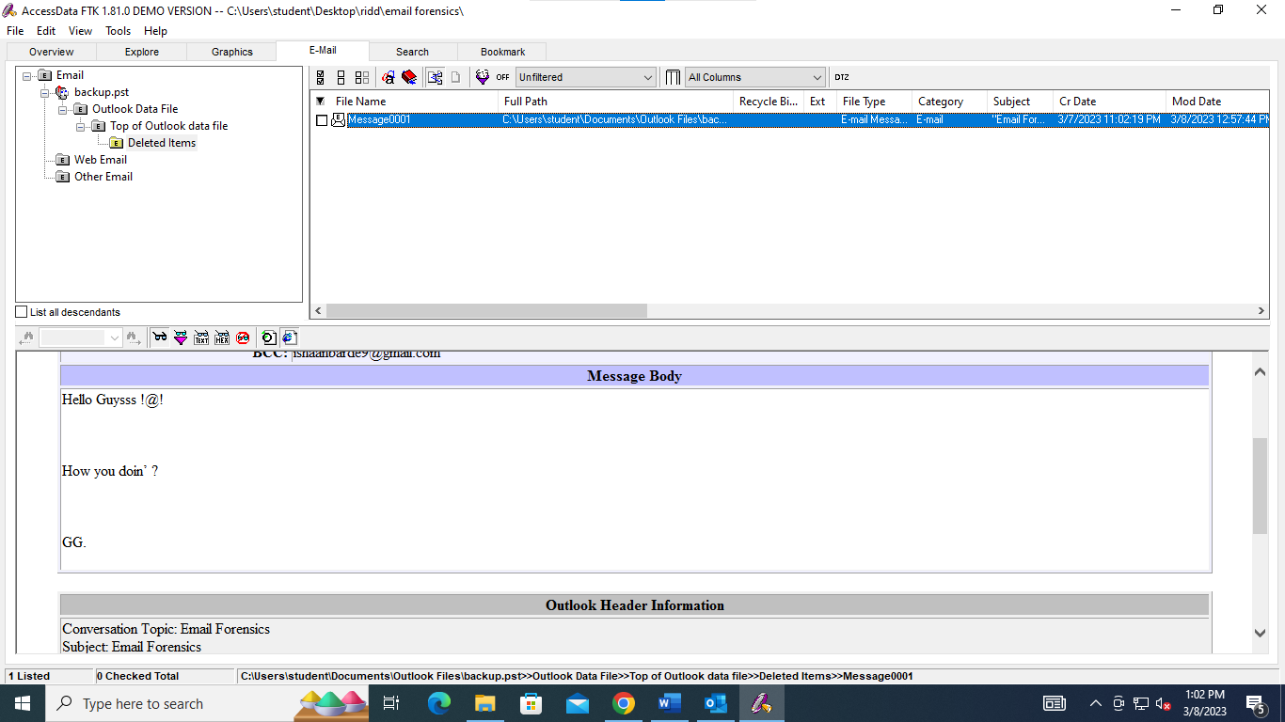

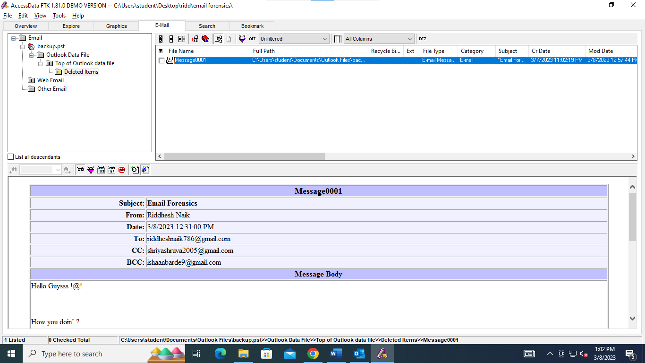

This are all the emails in the inbox of Outlook

